Emoji Brainstorm

**Goals and Expectations**1. What is the goal of the project?

2. How will you know if it’s successful?

3. Which concepts that we covered in this unit should be included in your code?

4. Which **optional** concepts can you try to use as an extra challenge?

**Inspiration:** Find emojis that you like and draw them below:

**Sketch:** Sketch at least 3 ideas in the boxes on the left, and answer the questions on the right.

| **This emoji is called:** | **How does it represent your community? How would people use it?** |
| --- | --- |
| **This emoji is called:** | **How does it represent your community? How would people use it?** |
| **This emoji is called:** | **How does it represent your community? How would people use it?** |

Emoji Design

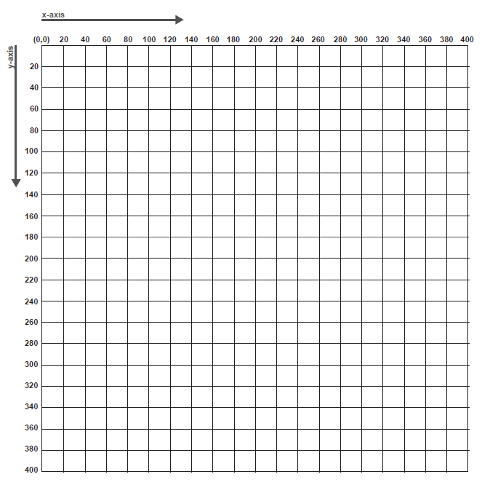

Plan

**Pseudocode**

What steps will you take to implement this idea? Be as specific as possible:

p5.js Shape Function Reference

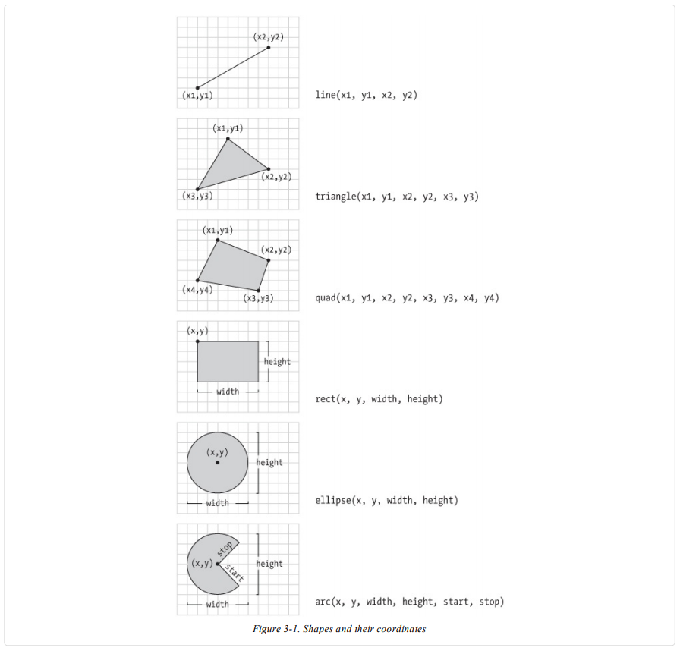

Process

**Create**

Use the planning section from your emoji design worksheet to begin coding. For each shape or visual element you try to draw in p5, fill out the table below.

| **Step #** | **What were you trying to do?** | **Did it work?**  **(Y/N)** | **If no, what happened instead?** |
| --- | --- | --- | --- |
|  |  |  |  |
|  |  |  |  |
|  |  |  |  |
|  |  |  |  |
|  |  |  |  |
|  |  |  |  |
|  |  |  |  |
|  |  |  |  |
|  |  |  |  |
|  |  |  |  |
|  |  |  |  |

**Test/Evaluate**

1. Does the design meet the criteria in the rubric? Explain.

2. What do you like about the design? Name the parts that are successful:

3. What parts of the design are unclear or visually confusing?

4. If your design doesn’t meet the criteria in the rubric, what do you need to add? If it does meet the criteria, what can be changed to improve the design?

**Improve**

List what you need to change to meet the rubric’s criteria. If you have met the criteria, choose 1 - 3 design aspects to improve:

Plan/Pseudocode:

Peer Feedback

| **Name** | **What do you really like about the project?** |
| --- | --- |
|  |  |
|  |  |
|  |  |

| **Name** | **What would you improve? Give a suggestion.** |
| --- | --- |
|  |  |
|  |  |
|  |  |

| **Name** | **What is one question you have about the project?** |
| --- | --- |
|  |  |
|  |  |
|  |  |

Self-Reflection

1. What were the most successful parts of your project? Review the **Peer Feedback** sheet to help you answer.

2. What parts of your project could be improved? Review the **Peer Feedback** sheet to help you answer.

3. When did you get stuck? What strategies did you use to get unstuck?

4. What is one thing you learned that you didn’t know before you began this project?